

Saint James’ Episcopal Church
April 2013
Sunday | Monday | Tuesday | Wednesday | Thursday | Friday | Saturday
F A M I L Y P R O M I S E H O S T W E E K | 1  Office Closed | 2   | 3  10 AM Holy Eucharist  and Healing Service  Evening Prayer 6:15 PM | 4  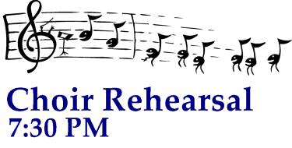 | 5  Office Closed | 6
7  8:00 am Holy Eucharist  9:00 am SMACA  10:15 am Holy Eucharist  11:30 am Hospitality | 8  Office Closed | 9 | 10  10 AM Holy Eucharist  and Healing Service  Evening Prayer 6:15 PM | 11 | 12  Office Closed | 13
14  8:00 am Holy Eucharist  9:00 am SMACA  10:15 am Holy Eucharist  11:30 am Hospitality | 15    Vestry- 7:15 PM  Office Closed | 16    7 PM  At the  Bimbi’s | 17  Holy Eucharist  and Healing Service  10:00 am  Evening Prayer 6:15 PM | 18 | 19  Office Closed | 20
21  8:00 am Holy Eucharist  9:00 am SMACA  10:15 am Holy Eucharist  11:30 am Hospitality | 22  Office Closed | 23  7 PM  At the  Bimbi’s | 24  Holy Eucharist  and Healing Service  10:00 am  Evening Prayer 6:15 PM | 25 | 26  Office Closed | 27
28  9:00 am Holy Eucharist  10:15 am Annual Meeting & Brunch   | 29  Office Closed | 30  7 PM  At the  Bimbi’s

