

Saint James’ Episcopal Church
August 2013
Sunday | Monday | Tuesday | Wednesday | Thursday | Friday | Saturday
 |  |  |  | 1 | 2  Office Closed | 3
4  8:00 a.m. Holy Eucharist  9:30 a.m. Holy Eucharist  10:30 a.m. Hospitality | 5  Office Closed |   6 | 7  10 A.M. Holy Eucharist  and Healing Service  Evening Prayer 6:15 PM | 8 | 9  Office Closed | 10
11  8:00 a.m. Holy Eucharist  9:30 a.m. Holy Eucharist  10:30 a.m. Hospitality | 12    Vestry- 7:15 PM  Office Closed | 13 | 14  Holy Eucharist  and Healing Service  10:00 a.m.  Evening Prayer 6:15 PM | 15 | 16  Office Closed | 17
18  F A M I L Y H O S T W E E K  8:00 a.m. Holy Eucharist  9:30 a.m. Holy Eucharist  10:30 a.m. Hospitality | 19  Office Closed | 20 | 21  Holy Eucharist  and Healing Service  10:00 a.m.  Evening Prayer 6:15 PM | 22 | 23  Office Closed | 24
25  8:00 a.m. Holy Eucharist  9:30 a.m. Holy Eucharist  10:30 a.m. Hospitality | 26  Office Closed | 27 | 28  Holy Eucharist  and Healing Service  10:00 a.m.  Evening Prayer 6:15 PM | 29  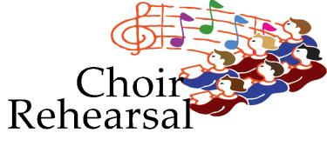  7:30 PM | 30  Office Closed | 31

