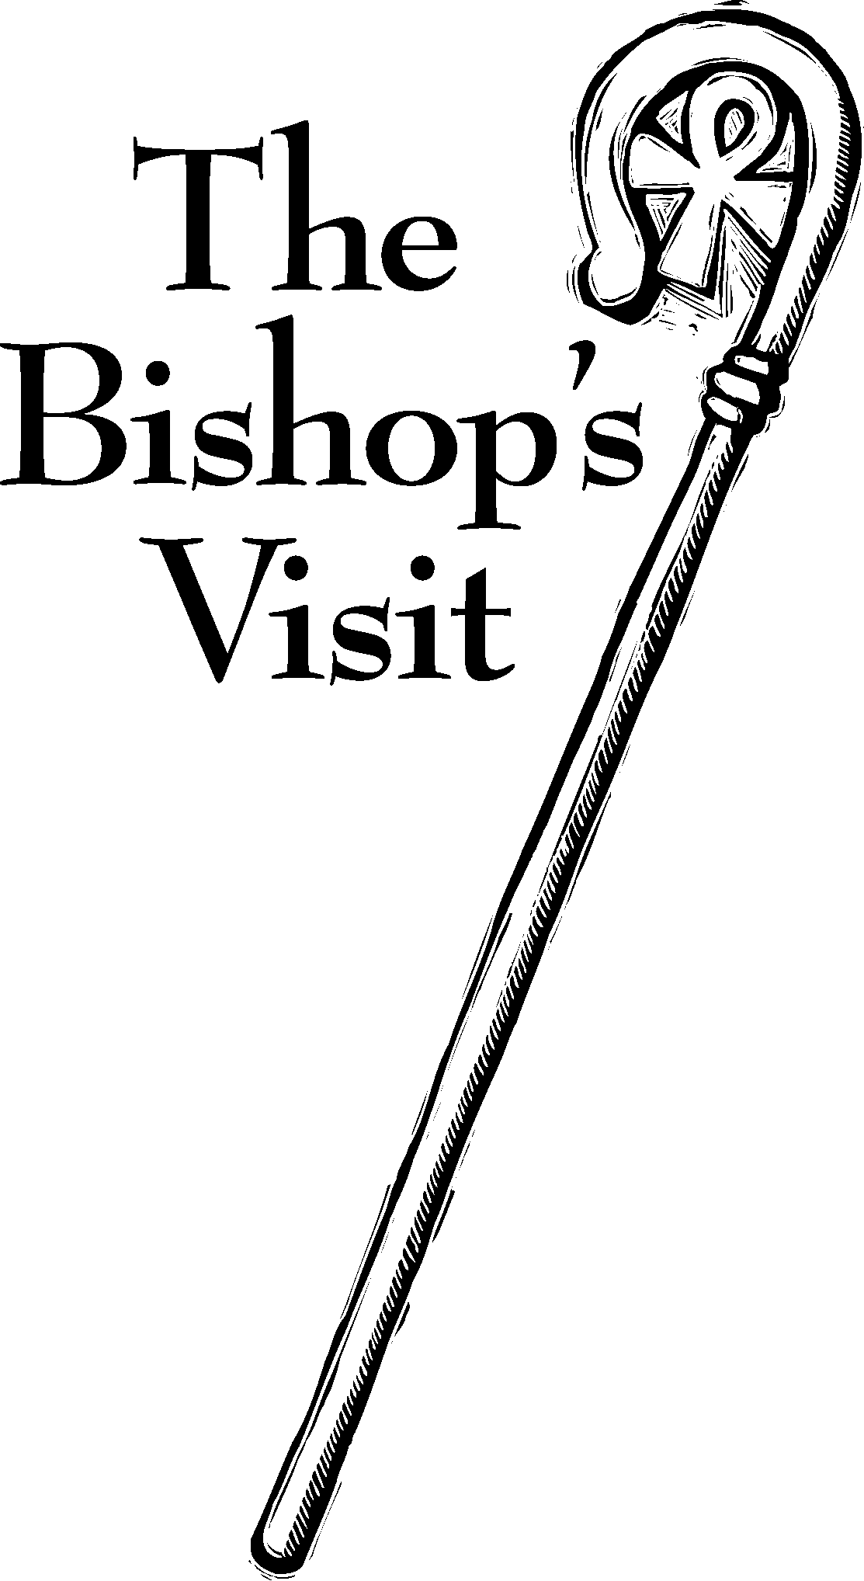

Saint James’ Episcopal Church
January 2013
Sunday | Monday | Tuesday | Wednesday | Thursday | Friday | Saturday
 |  | 1    Office Closed | 2  Holy Eucharist  and Healing Service  10:00 am | 3  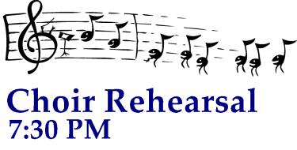 | 4  Office Closed | 5
7    8:00 am HolyEucharist  9:00 am SMACA  10:15 am Holy Eucharist  11:30 am Hospitality | 7  7PM    Office Closed | 8    At the Bimbi’s  7 PM | 9  Holy Eucharist  and Healing Service  10:00 am  Evening Prayer 6:15 PM | 10 | 11  Office Closed | 12
13  8:00 am HolyEucharist  9:00 am SMACA  10:15 am Holy Eucharist  11:30 am Reception for Bishop Wright & the Confirmands | 14    Vestry  Lounge 7:15 PM Office Closed | 15  at the Bimbi’s  7 PM | 16  Holy Eucharist  and Healing Service  10:00 am  Evening Prayer 6:15 PM | 17 | 18  Office Closed | 19
20  8:00 am HolyEucharist  9:00 am SMACA  10:15 am Holy Eucharist  11:30 am Hospitality |   21    1 PM  Office Closed | 22  7 PM  at the Bimbi’s | 23  Holy Eucharist  and Healing Service  10:00 am  Evening Prayer 6:15 PM | 24 | 25  Office Closed | 26
27  8:00 am HolyEucharist  9:00 am SMACA  10:15 am Holy Eucharist    11:30 am | 28  Office Closed | 29  at the Bimbi’s  7 PM | 30  Holy Eucharist  and Healing Service  10:00 am  Evening Prayer 6:15 PM | 31

