

Saint James’ Episcopal Church
February 2013
Sunday | Monday | Tuesday | Wednesday | Thursday | Friday | Saturday
 |  |  |  |  | 1  Office Closed | 2
3  8:00 am Holy Eucharist  9:00 am SMACA  10:15 am Holy Eucharist  11:30 am Hospitality | 4  7PM    Office Closed | 5      BIBLE STUDY AT THE BIMBI’s 7 PM | 6  Holy Eucharist  and Healing Service  10:00 am  Evening Prayer 6:15 PM | 7  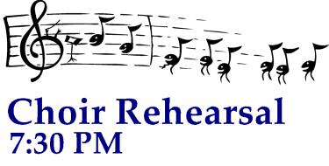 | 8  Office Closed | 9
10  8:00 am Holy Eucharist  9:00 am SMACA  10:15 am Holy Eucharist  11:30 am Hospitality | 11    Vestry  Lounge 7:15 PM  Office Closed | 12  Shrove Tuesday  6.15 PM  Tickets reqd. | 13  7AM    Noon  7PM | 14   | 15  Office Closed | 16
17  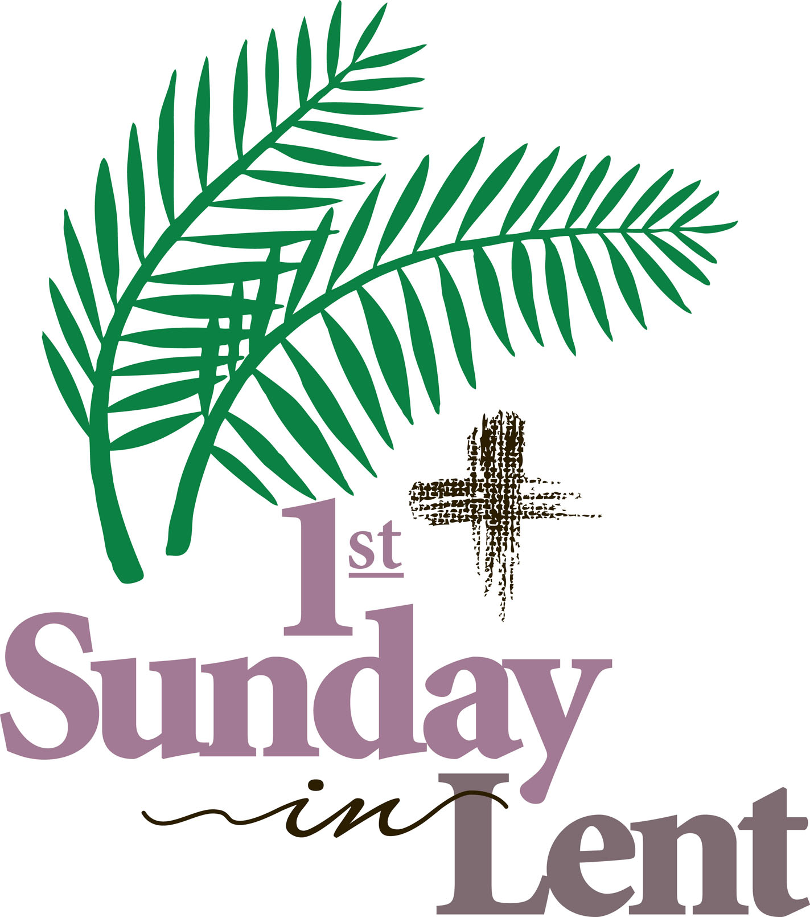  8:00 am Holy Eucharist  9:00 am SMACA  10:15 am Holy Eucharist  11:30 am Hospitality | 18  Office Closed | 19 | 20  Holy Eucharist  and Healing Service  10:00 am  Noon Ecumenical Lenten Service at  Marshalton UMC  Evening Prayer 6:15 PM | 21 | 22  Office Closed | 23
24  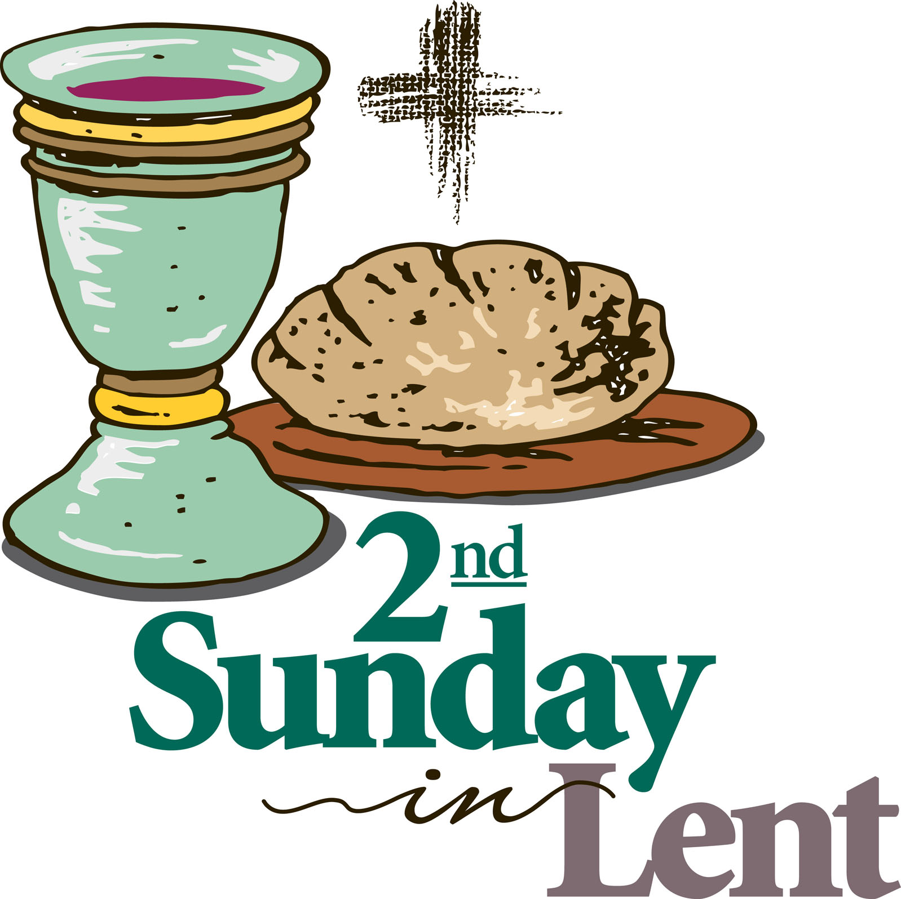  8:00 am Holy Eucharist  9:00 am SMACA  10:15 am Holy Eucharist  11:30 am Hospitality | 25  Office Closed | 26 | 27  Holy Eucharist  and Healing Service  10:00 am  Noon Ecumenical Lenten Service at  Marshalton UMC  Evening Prayer 6:15 PM | 28

