

Saint James’ Episcopal Church
March 2013
Sunday | Monday | Tuesday | Wednesday | Thursday | Friday | Saturday
 |  |  |  |  | 1  Office Closed | 2
3  8:00 am Holy Eucharist  9:00 am SMACA  10:15 am Holy Eucharist  11:30 am Hospitality  11:45 am Parish Life Meeting | 4  Office Closed | 5      Soup & Book Study at the Bimbi’s 6PM | 6  10 AM Holy Eucharist  and Healing Service  Noon Ecumenical Lenten Service at  Marshalton UMC  Evening Prayer 6:15 PM | 7  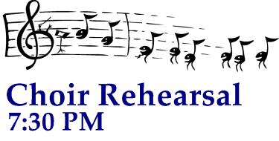 | 8  Office Closed | 9
  10  8:00 am Holy Eucharist  9:00 am SMACA  10:15 am Holy Eucharist  11:30 am Hospitality | 11    Vestry- 7:15 PM  Office Closed | 12  Soup & Book Study at the Bimbi’s 6PM | 13  10 AM Holy Eucharist  and Healing Service  Noon Ecumenical Lenten Service at  Marshalton UMC  Evening Prayer 6:15 PM | 14 | 15  Office Closed | 16
17  8:00 am Holy Eucharist  9:00 am SMACA  10:15 am Holy Eucharist  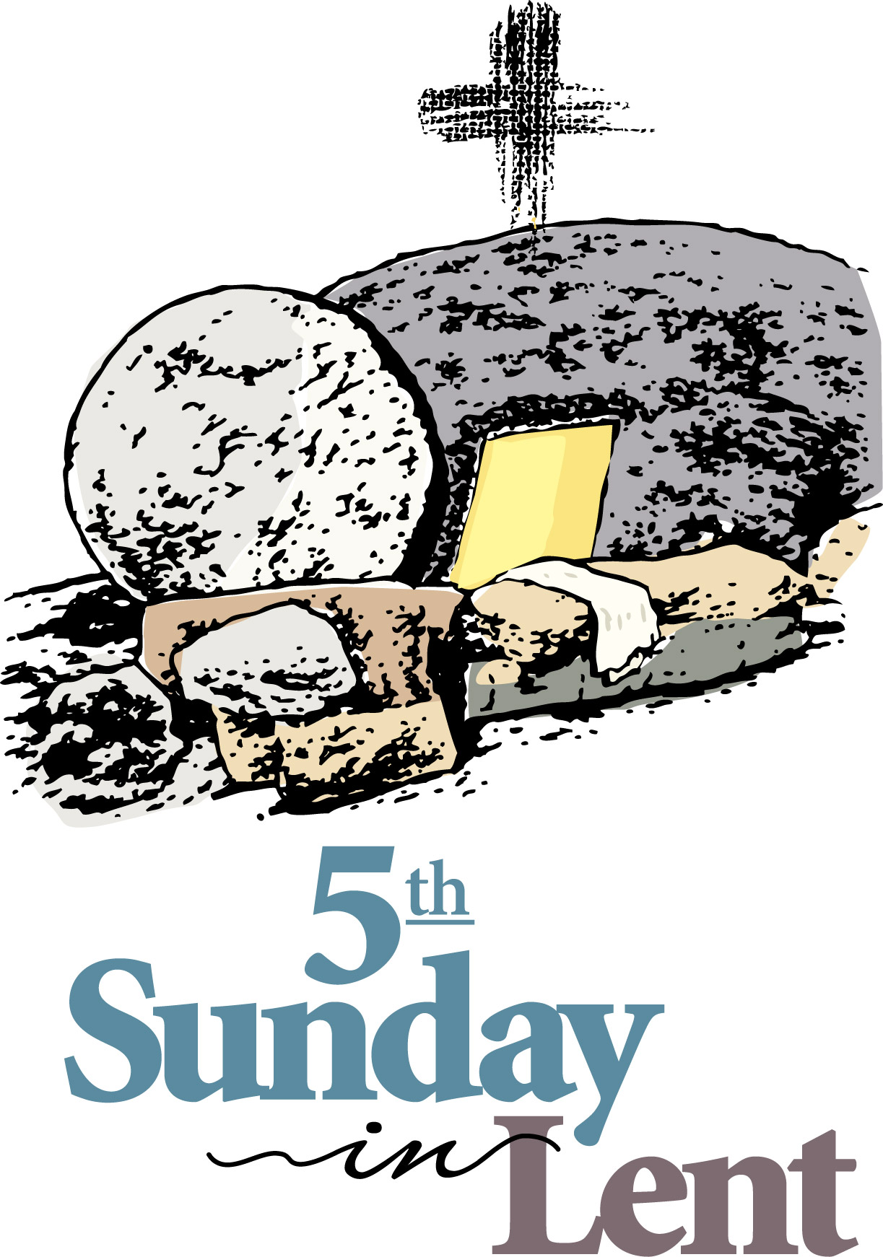  11:30 am Hospitality  4:00 pm ♫ Lenten Concert at St. Barnabas’ ♫ | 18    1 PM  Office Closed | 19  Soup & Book Study at the Bimbi’s 6 PM | 20  Holy Eucharist  and Healing Service  10:00 am  Noon Ecumenical Lenten Service at  Marshalton UMC  Evening Prayer 6:15 PM | 21 | 22  Office Closed | 23    8AM-3PM
24  8:00 am  Holy Eucharist  9:00 am SMACA    10:15 am Holy Eucharist  11:30 am Hospitality | 25  Office Closed | 26 | 27  Holy Eucharist  and Healing Service  10:00 am  Noon Ecumenical Lenten Service at  Marshalton UMC  Evening Prayer 6:15 PM | 28  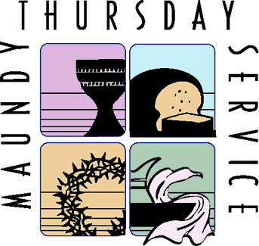  7:30 PM | 29 Episcopal  Liturgy 10AM  Ecumenical  At Noon  7 Last Words   | 7  Prayer Service 9AM    & hot dog lunch  11AM
31  8:00 am Holy Eucharist  9:00 am SMACA    10:15 am Holy Eucharist  11:30 am Hospitality |  |  |   Don’t forget to set your clocks ahead for the March 10th time change. Daylight Saving time begins the 2nd Sunday of March.

