

Saint James’ Episcopal Church
December 2012
Sunday | Monday | Tuesday | Wednesday | Thursday | Friday | Saturday
 |  |  |  |  |  | 1
2  1st Sunday of Advent  8:00 am HolyEucharist  9:00 am SMACA  10:15 am Holy Eucharist  11:30 am Hospitality | 3    7PM | 4 | 5  Holy Eucharist  and Healing Service  10:00 am  Evening Prayer 6:15 PM | 6  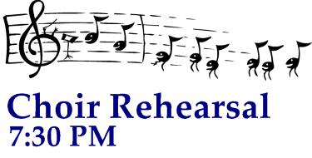 | 7  Office Closed | ♫ 8 ♫  ♫ OPUS ONE HOLIDAY CONCERT 7 PM Benefits Family Promise & ERD Hurricane SANDY Relief ♫
9  2nd Sunday of Advent  8:00 am HolyEucharist  9:00 am SMACA  10:15 am Holy Eucharist  11:30 am Hospitality | 10    Vestry  Lounge 7:15 PM | 11 | 12  Holy Eucharist  and Healing Service  10:00 am  Evening Prayer 6:15 PM | 13 | 14  Office Closed | 15
16  3rd Sunday of Advent Family Promise Host Week  8:00 am HolyEucharist  9:00 am SMACA  10:15 am Holy Eucharist  11:30 am Hospitality | 17   | 18 | 19  Holy Eucharist  and Healing Service  10:00 am  Evening Prayer 6:15 PM | 20 | 21  Office Closed | 22
23  4th Sunday of Advent  8:00 am HolyEucharist  9:00 am SMACA  10:15 am Holy Eucharist  11:30 am Hospitality | 24  4:00 Family  Communion Service  8:00 Youth Led Holy Eucharist  11PM Traditional Christmas Eucharist | 25  Christmas CommunionService  9 AM   | 26  Office Closed | 27  Office Closed | 28  Office Closed | 29
30  Christmas 1  8:00 am HolyEucharist  9:00 am SMACA  10:15 am Holy Eucharist  11:30 am Hospitality | 31

