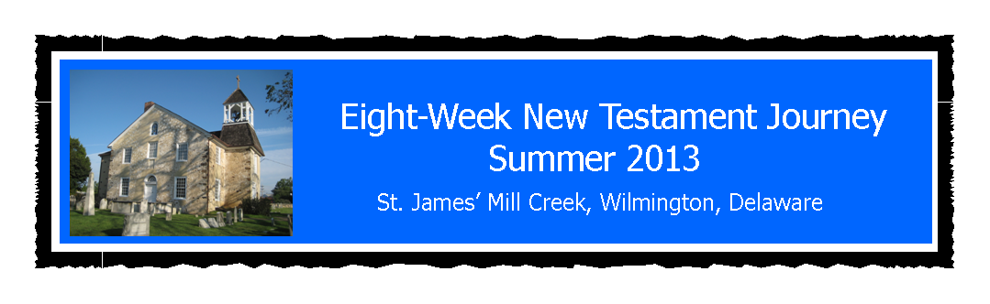

**July 10, 2013**

**"Walking with Jesus and his Followers"**

Last summer a number of Delaware Episcopal congregations participated in the 90-Day Bible Challenge. Reading the Bible cover-to-cover in 3 months took a lot of time and effort out of one's day. Those who completed all the readings experienced a bit of exhaustion. My personal exhaustion resulted from writing a daily blog of the Challenge for 90 consecutive days, but I felt that I gained much by doing so. My concern is that last year more than a few people got waylaid long before they reached the New Testament, or were so overwhelmed by the amount of reading that much of the power and message might have been missed.

So, this year I have created my own "challenge," 37 percent shorted in duration with only one quarter of the daily reading requirement! It will not cover all of the writings of the New Testament. Rather we will set the stage by reading the Gospels according to Matthew and Luke to get the teachings and ministry of Jesus firmly in mind. Next will come a reading of the Acts of the Apostles, which will be interrupted at those points in the narrative when Paul wrote his letters to the early communities of believers. For example, Paul wrote his letters to the believers in Thessalonica around the year 52 AD during the 18 months was staying in Corinth. So, the reading of Acts will be interrupted at Acts 18:17 while we read 1 & 2 Thessalonians. We will then pick up the story in Acts until Paul reaches Ephesus, from where he wrote his first letter to the Corinthians. This will be the pattern until Paul ends up in Rome and completes his letters to the churches. Finally, we will circle back around to the Gospels and read through John's account - with all its poetic and grand imagery coming out of the late New Testament period.

Well, that's it. My intention is to write a daily blog throughout this Eight-Week New Testament Journey, adding my thoughts, observations, and a few comments along the way. The address for the blog is http://8WeekNTjourney.blogspot.com and if you have internet access I hope that you'll join me, and also welcome your comments on my posts. It's a lot more rewarding to have a conversation, so please don't hesitate to let me know what's on your mind.

Blessing, Fr. Jim Bimbi

Schedule of readings is attached below.

**St. James’ Mill Creek Hundred**

**Summer 2013 Eight-Week Bible Journey**

***“Galilee, Jerusalem, and Beyond”***

**WEEK ONE**

Read √ Day Date Reading

* 1. Sunday 07-14 Matthew 1:1—4:25
* 2. Monday 07-15 Matthew 5:1—6:34
* 3. Tuesday 07-16 Matthew 7:1—9:38
* 4. Wednesday 07-17 Matthew 10:1—12:32
* 5. Thursday 07-18 Matthew 12:33—14:36
* 6. Friday 07-19 Matthew 15:1—18:9
* 7. Saturday 07-20 Matthew 18:10—21:17

**WEEK TWO**

Read √ Day Date Reading

* 8. Sunday 07-21 Matthew 21:18—23:39
* 9. Monday 07-22 Matthew 24:1—26:35
* 10. Tuesday 07-23 Matthew 26:36—28:20
* 11. Wednesday 07-24 Luke 1:1—2:38
* 12. Thursday 07-25 Luke 2:39—4:44
* 13. Friday 07-26 Luke 5:1—6:49
* 14. Saturday 07-27 Luke 7:1—8:56

*Fr. Jim’s Blog – http://8WeekNTjourney.blogspot.com Page 1*

**St. James’ Mill Creek Hundred**

**Summer 2013 Eight-Week Bible Journey**

***“Galilee, Jerusalem, and Beyond”***

**WEEK THREE**

Read √ Day Date Reading

* 15. Sunday 07-28 Luke 9:1 – 10:37
* 16. Monday 07-29 Luke 10:38 – 12:34
* 17. Tuesday 07-30 Luke 12:35 –14:35
* 18. Wednesday 07-31 Luke 15:1 –18:14
* 19. Thursday 08-01 Luke 18:15 – 20:47
* 20. Friday 08-02 Luke 21:1 – 22:71
* 21. Saturday 08-03 Luke 23:1 – 24:53

**WEEK FOUR**

Read √ Day Date Reading

* 22. Sunday 08-04 Acts 1:1 – 3:26
* 23. Monday 08-05 Acts 4:1 – 6:15
* 24. Tuesday 08-06 Acts 7:1 – 8:40
* 25. Wednesday 08-07 Acts 9:1 – 11:18
* 26. Thursday 08-08 Acts 11:19 – 14:7
* 27. Friday 08-09 Acts 14:8 – 16:40
* 28. Saturday 08-10 Acts 17:1 – 18:17

1 Thessalonians 1:1 – 3:13

*Fr. Jim’s Blog – http://8WeekNTjourney.blogspot.com Page 2*

**St. James’ Mill Creek Hundred**

**Summer 2013 Eight-Week Bible Journey**

***“Galilee, Jerusalem, and Beyond”***

**WEEK FIVE**

Read √ Day Date Reading

* 29. Sunday 08-11 1 Thessalonians 4:1 –5:28

2 Thessalonians 1:1 – 3:18

* 30. Monday 08-12 Acts 18:18 – 19:22

1 Corinthians 1:1 – 3:23

* 31. Tuesday 08-13 1 Corinthians 4:1 – 8:13
* 32. Wednesday 08-14 1 Corinthians 9:1 – 12:31
* 33. Thursday 08-15 1 Corinthians 13:1 – 15:58
* 34. Friday 08-16 1 Corinthians 16:1-24

Galatians 1:1 – 3:18

* 35. Saturday 08-17 Galatians 3:19 – 6:18

**WEEK SIX**

Read √ Day Date Reading

* 36. Sunday 08-18 Acts 19:23 – 20:1

2 Corinthians 1:1 – 4:15

* 37. Monday 08-19 2 Corinthians 4:16 – 9:15
* 38. Tuesday 08-20 2 Corinthians 10:1 – 13:13
* 39. Wednesday 08-21 Acts 20:2-3a

Romans 1:1 – 4:25

* 40. Thursday 08-22 Romans 5:1 – 8:39
* 41. Friday 08-23 Romans 9:1 – 12:21
* 42. Saturday 08-24 Romans 13:1 – 16:27

*Fr. Jim’s Blog – http://8WeekNTjourney.blogspot.com Page 3*

**St. James’ Mill Creek Hundred**

**Summer 2013 Eight-Week Bible Journey**

***“Galilee, Jerusalem, and Beyond”***

**WEEK SEVEN**

Read √ Day Date Reading

* 43. Sunday 08-25 Acts 20:3b – 22:30
* 44. Monday 08-26 Acts 23:1 – 25:27
* 45. Tuesday 08-27 Acts 26:1 – 28:31
* 46. Wednesday 08-28 Ephesians 1:1 – 6:24
* 47. Thursday 08-29 Philippians 1:1 – 4:23
* 48. Friday 08-30 Colossians 1:1 – 4:18
* 49. Saturday 08-31 John 1:1 – 3:36

Read √ Day Date Reading

* 50. Sunday 09-01 John 4:1 – 6:15
* 51. Monday 09-02 John 6:16 – 8:11
* 52. Tuesday 09-03 John 8:12 – 10:21
* 53. Wednesday 09-04 John 10:22 – 12:50
* 54. Thursday 09-05 John 13:1 – 16:24
* 55. Friday 09-06 John 16:25 – 18:16a
* 56. Saturday 09-07 John 18:16b – 21:25

*Congratulations! You did it!*

*Fr. Jim’s Blog – http://8WeekNTjourney.blogspot.com Page 4*