

Saint James’ Episcopal Church
May 2013
Sunday | Monday | Tuesday | Wednesday | Thursday | Friday | Saturday
 |  |  | 1  10 A.M. Holy Eucharist  and Healing Service  Evening Prayer 6:15 PM | 2  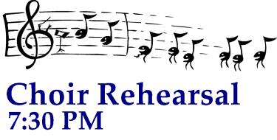 | 3  Office Closed | 4
5  8:00 a.m. Holy Eucharist  9:00 a.m. SMACA  10:15 a.m. Holy Eucharist  11:30 a.m. Hospitality | 6  Office Closed |   7 | 8  10 A.M. Holy Eucharist  and Healing Service  Evening Prayer 6:15 PM | 9  Ascension Day | 10  Office Closed | 11
12    8:00 a.m. Holy Eucharist  9:00 a.m. SMACA  10:15 a.m. Holy Eucharist  11:30 a.m. Hospitality | 13    Vestry- 7:15 PM  Office Closed | 14    7 PM  At the  Bimbi’s | 15  Holy Eucharist  and Healing Service  10:00 a.m.  Evening Prayer 6:15 PM | 16 | 17  Office Closed | 18
19  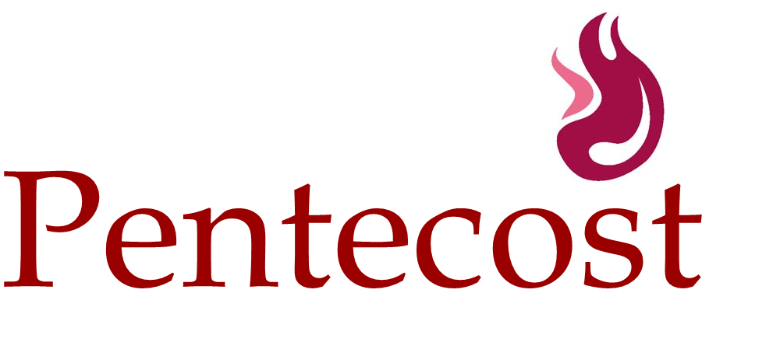  8:00 a.m. Holy Eucharist  9:00 a.m. SMACA  10:15 a.m. Holy Eucharist  11:30 a.m. Hospitality | 20  Office Closed | 21  7 PM  At the  Bimbi’s | 22  Holy Eucharist  and Healing Service  10:00 a.m.  Evening Prayer 6:15 PM | 23 | 24  Office Closed | 25
26    8:00 a.m. Holy Eucharist  10:15 a.m. Holy Eucharist  11:30 a.m. Hospitality | 27    Office Closed | 28  7 PM  At the  Bimbi’s | 29  Holy Eucharist  and Healing Service  10:00 a.m.  Evening Prayer 6:15 PM | 30 | 31  Office Closed

