A Letter from St. James

Mill Creek Hundred

November / December 2012

***Rector’s Ramblings. . .Sailing along with Christ***

It is just a few days before Thanksgiving Day as I sit down to write this episode of my *“Ramblings.”* By the time you read this I probably will have already left for my first ever post-Thanksgiving-pre-Christmas vacation trip. This past summer was also a first. It was the first time in my twenty years as a priest that I did not take at least one Sunday off. My reason was simple: I wanted to save my vacation time in order to take my wonderful wife on a cruise in honor of her \_\_th birthday *[I’ll let Cynde fill in the blank]*. And so on Sunday, November 25th, we are boarding a ship in New York for a weeklong cruise to Florida and The Bahamas. We are taking along our dancing shoes and snorkeling gear, and hope to get as much use out of them as we can. I have also booked us on a shore excursion in Florida that Cynde doesn’t know about. *[It’s a surprise; she won’t see this newsletter before we leave on the trip.]*  I hope she will still be speaking to me afterwards, because the excursion is an airboat river tour among the alligators, snakes, and other wildlife that are not high on her list of likeable creatures. Hey, you’ve got to take a few risks every now and then.

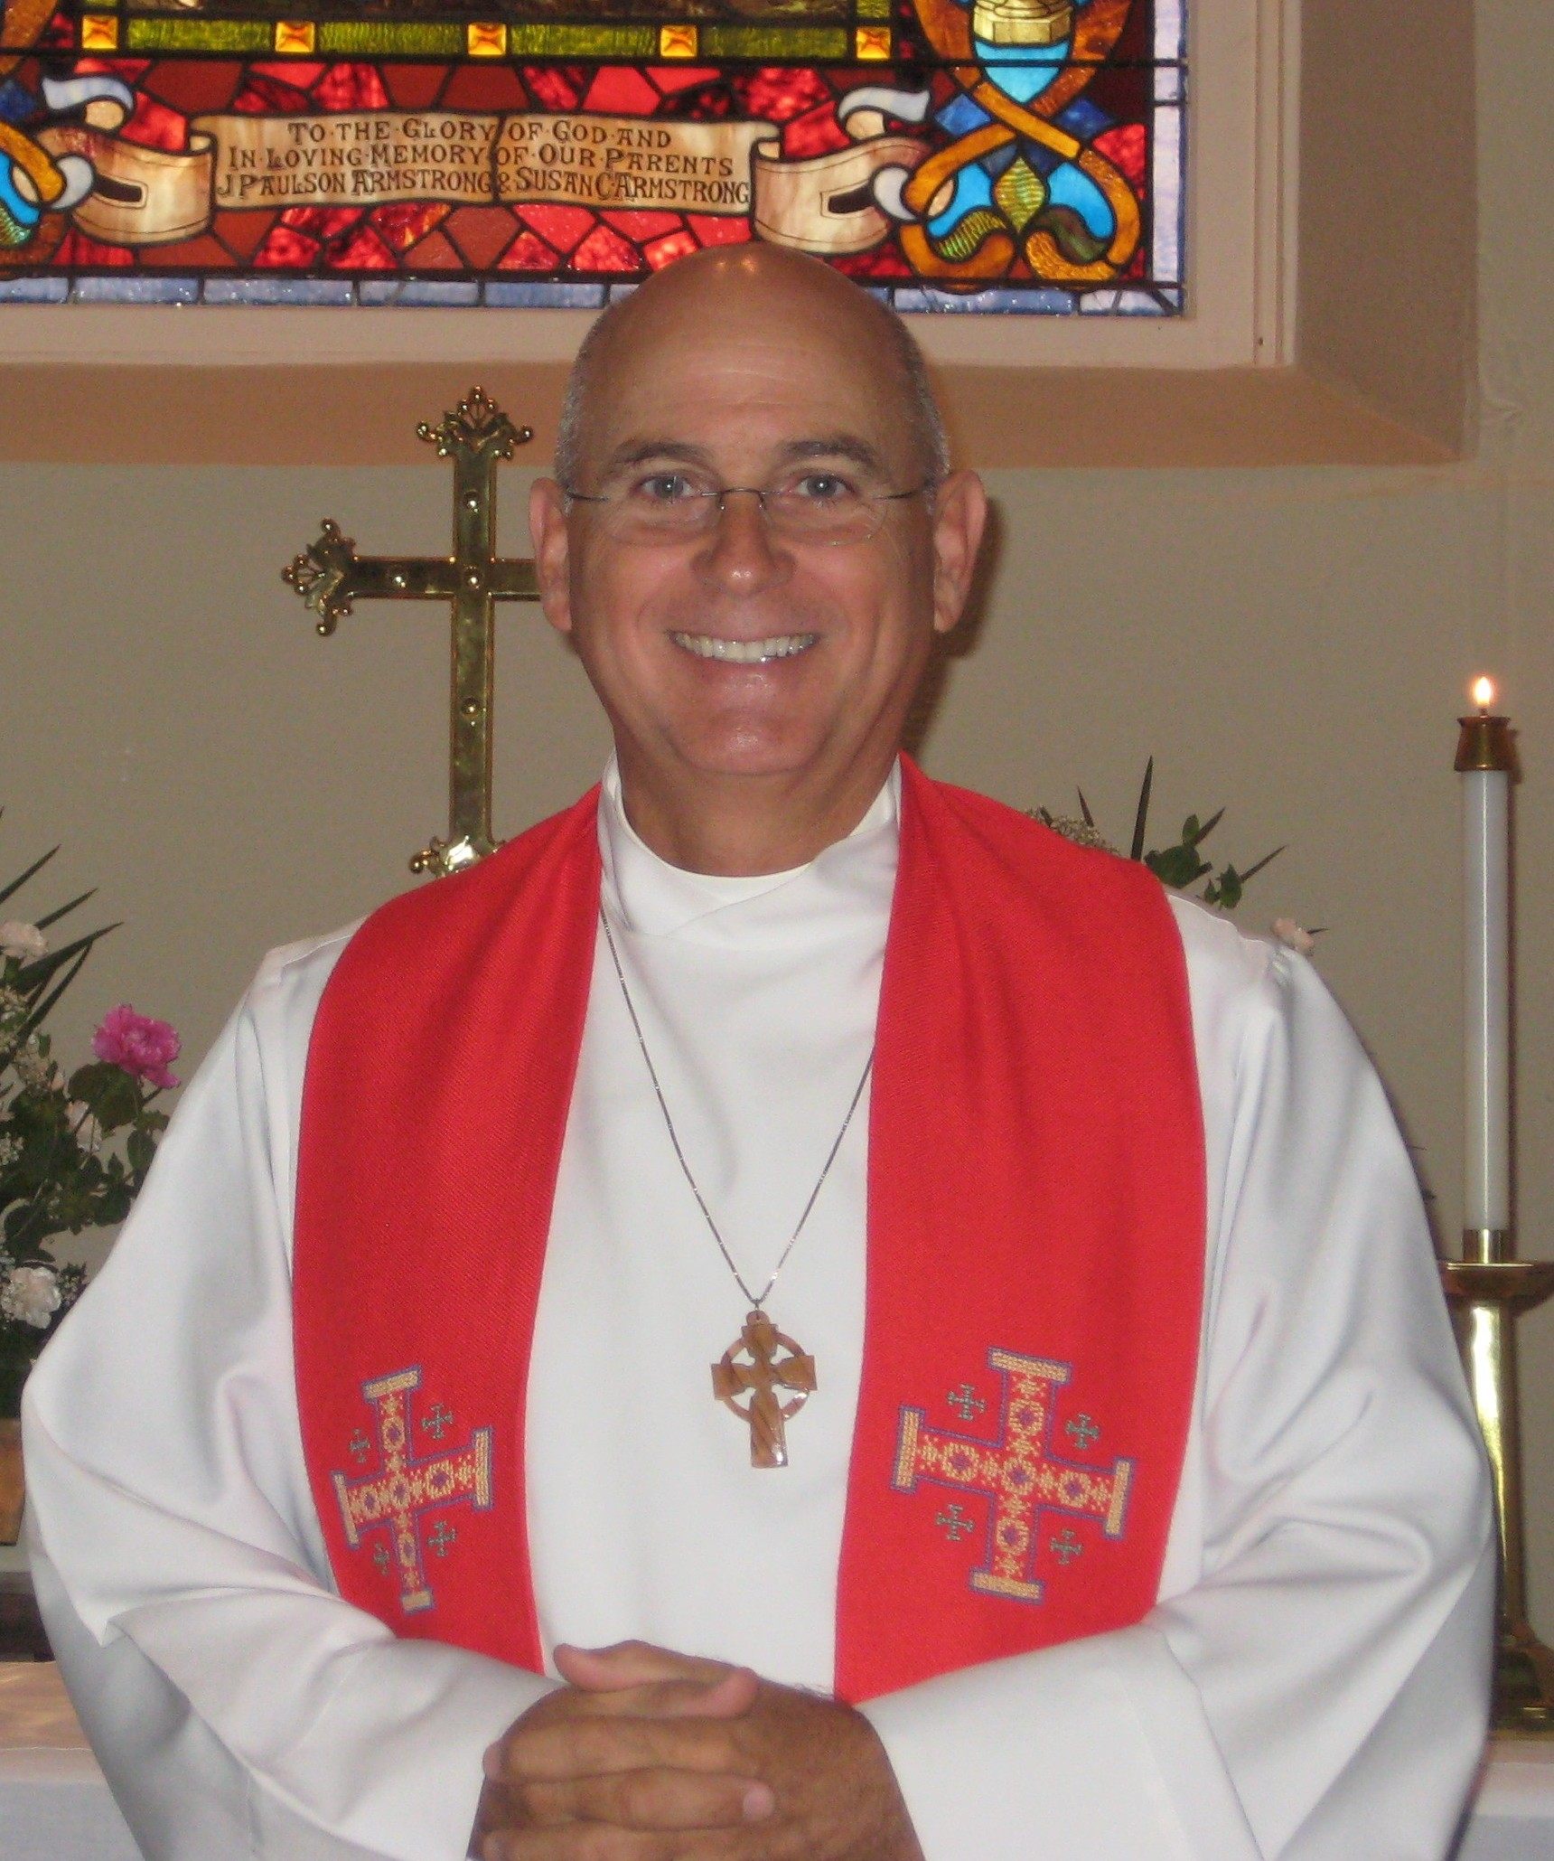

By the time we get back from our trip the church will have begun its observance of the season of Advent. The leftovers from Thanksgiving will have been cleaned out to make room for all of the goodies that are consumed up to and including Christmas Day. It’s interesting to note the different foods that we associate with our holidays, and the importance of the sharing of meals that are so much a part of our lives and celebrations. The rhythm of gathering together, of telling the stories, of remembering where we’ve been and dream about where we’re headed, are deeply ingrained in our collective experience at this time of year. They are also a part of our experience of the regular weekly worship and fellowship that we engage in. While what we as Christians do from week-to-week does not garner the same attention as Thanksgiving and Christmas, it is foundational to the joy that we receive from these year-end celebrations. What these holidays accentuate is the day-to-day Love of God that we have come to know through Jesus Christ.

While I have high hopes that my post-Thanksgiving-pre-Christmas voyage will be memorable, they are no higher than the assurances from God with which I live year round. Jesus – the Incarnate Word, the Son of God, and the Author of my Salvation – is my one everlasting joy. To Him I give endless praise, with him may I forever feast, for him shall I eternally set sail.

Fr. Jim Bimbi

[](http://meals-on-wheels.com/#url)**Meals on Wheels Program**

Every now and then I have been impressed with people (sports figures, entertainers and just common everyday people) who spent the whole day or a part of the day doing some service for their neighbors. I am made aware of their efforts because they are occasionally featured on some news broadcast or in the newspaper.

I would like to bring to your attention that there a number of members of St. James’ who on a regular basis provide a servie to our neighbors. We do this on a regular basis but we have no TV crew or newspaper documenting our efforts, however, we do receive a reward; the good feeling from knowing that we have acted as our brother’s keeper and that we have benefited as much as those to whom we provide service.

We invite you to join us in participating in the “***Meals on Wheels Program***”. Along with a partner from St. James’ we pick up prepared noon-day meals and deliver them to our neighbors in the area surrounding St. James’. The time spent is about 45 minutes starting at 11:00 a.m.

We have had, in the past, a sufficient number of St. James’ parishioners volunteering their time so that with few exceptions no one needs to participate more than 3 times a year. However, because of medical problems and other reasons several of our volunteers can no longer continue. WE NEED YOUR HELP! If you have 2 or 3 days in a year in which you would be willing to transport food to the needy in this area, please give Ed Clark a call. I can be reached at these telephone numbers 836-8026 or 354-6508.  *Ed Clark*

***ANOTHER SUCCESSFUL BAZAAR!***

The Bazaar, Luncheon and Turkey Dinner were a success again this year. We were busy both days. There were many compliments from those who shopped and enjoyed the luncheon and/or dinner. St. James is very fortunate to have so many members who are willing to give of their time and talents to make the Bazaar Weekend a winner each year.

The Bazaar Ladies extend a big ***“THANK YOU”*** to everyone who helped. Thank you to the bakers who supplied the Bake Shop, crafters who donated hand crafted items, everyone who donated food, cooked turkeys, prepared and served the Luncheon and Turkey Dinner, those who filled in and helped in the shops, raffle table, the volunteers who helped set up and the group that cleaned up. **A very special “Thank You” goes to the** **young people who were servers at the Turkey Dinner**. We appreciate everything that was done and we thank everyone. We couldn’t do it without you.

**JOB WELL DONE!**

***A SPECIAL THANK YOU!***

We also want to extend a very special THANK YOU to *Crossroads Restaurant* for donating the coleslaw for our Turkey Dinner and to *Henry’s Exxon* for donating a gift card for one of our door prizes. Henry’s Exxon has been a loyal supporter of the Bazaar for many years.

***THANK YOU*** Jack Parker for the *beautiful* cross-stitch for the silent auction!

## AND THE WINNERS ARE

## *Silent Auction:*

## Framed Cross Stitch Picture stitched by Jack Parker – George Shogan

**Quilt Raffle:** Queen Size Quilt with Matching Pillows – **Karen Shogan**

**Raffle Table Items:**

Crib Quilt – **S. Lanonette**

Nativity Scene – **Carley Bond**

Victorian Tree – **Karil Henry**

Appliquéd Angel Wall Hanging – **Nancy Patterson**

**Door Prizes:**

Exxon Gift Card – **Margaret Gungui**

Bird Watcher’s Basket – **Janice Sukeena**

**Cake Raffle:**

Snowman Cake – **Diane Rupard**

**Congratulations to this year’s winners! Thank you for your participation and support.**

**Don’t Forget to Save Your Zingo Tapes**

Please remember to save your Zingo tapes and leave them in the container in the foyer closet of the parish house. This past year we received over $400 for tapes we submitted. This helps with Bazaar costs.

**Keep bringing in those tapes! *Thank you!***

**Best Wishes for a Happy Holiday Season!!**

**A MESSAGE FROM THE BAKE SHOP:**

***THANK YOU*** for all the goodies. Our tables looked great at the start of the day Friday and Saturday.  They looked even better at the end of the day Saturday when just about everything had been sold. Without your delicious home made items we wouldn’t be successful.

***HAVE A GOOD* *YEAR*.**

THANKS AGAIN, Shirley Alexander and Carolyn Eldridge

thankbigc.tifIt would take the entire page to thank by name everyone who contributed to making the Turkey Dinner a success.  Thank you to everyone who sold tickets, arranged and set tables, donated food, carved turkeys, prepared food, baked pies, scraped and washed dishes, served tables, and ate!  This was truly a team effort.  I think I would be remiss if I didn't thank some people personally.  A HUGE thank you to Barbara Anzilotti, who may think twice before she lets me "volunteer" her for a project again.  With my work schedule, Barbara's help with the day to day details was invaluable. Bill Short for selling tickets and organizing the seating to make sure not only did we sell out, but everyone got to sit with their party.  Fr. Jim, Jerry Clark, and Eileen Marvel for sharing their wisdom and experience from past dinners with the newbies.  Debbie and John Nuss who baked all the pies.  Cynde Bimbi for graciously and expertly organizing the take-out dinners.  The youth who gave up their Saturday afternoon and evening to wait tables and clean up.  It was wonderful to see some of the "old hands" working alongside some new recruits.  The Turkey Dinner was St. James' team spirit in action.  Thank you! *-Kathy Kwiatkowski*

calendar -these.tif  
Ladies. Don’t forget the **Lenten Retreat** on Feb 22-24 at Memorial House.  The Theme is ***"Know Chocolate for Lent"***. The retreat will be led by Sister BJ.  Cost is $210 per person for two nights and meals. Checks should be made out to St James Church, with "Lenten Retreat" on the memo line.

C:\Users\gthomas\AppData\Local\Microsoft\Windows\Temporary Internet Files\Content.IE5\0EM36WGR\MC900363562[1].wmf  
The **9th Annual** presentation of **“Keep Christ in Christmas”** will be held on **Sunday, December 16th**, from **9am to 4pm** at The Church of the Ascension, located in Claymont at 3717 Philadelphia Pike, near the entrance to I-495. More than 100 Nativities will be on display from around the world in a variety of styles and media. There will be displays for children as well. Plan to make time for this very special free exhibit and enjoy light refreshments and beautiful Christmas music while you unwind for a while away from the stresses of the holidays.

**On Sunday, December 23, at** Sts. Andrew & Matthew in Wilmington, at **7:00 pm,** the **Cathedral Choir School** will present the beautiful **Service of Nine Lessons and Carols**, based on the Christmas Eve Festival of Nine Lessons and Carols, sung annually for nearly a century by the Choir of King’s College, Cambridge, and broadcast live around the world.

adopt1c.tifThis year, St. James' will sponsor two families.  Please consider making a donation (any amount).  The last day to donate is Sunday, Dec. 2.  Donations should be placed in the offering plate.  Checks should be made out to St. James' Church, with the notation:  "Needy Family."  Gift cards will be purchased at the store requested by the families.

These are very worthy families who need our help.  Here is the outline for the families:

The first family is a teen mom who is raising 2-month-old infant twins -- a girl and a boy.  Her housing is unstable; she resides with friends for periods of time.  She has minimal finances, which makes it difficult to care for her twins and to find stable housing.  The twins were born prematurely.

The second family is a mother who is caregiver for her 5-month-old grandson whose mother is incarcerated.  This lady underwent major heart surgery in September; some complications resulted.  Also, she is caring for a 17-yr-old female who is disabled and attends a special school.  The other children are two boys (12 and 13 yrs) and a girl (7 yrs). This mother struggles to make ends meet and is stressed about all the responsibilities that come with caring for her grandson and children.  
Any help you can offer these families will be greatly appreciated.

food_1129c.tifThank you from the Mission/Outreach Committee.

Don’t forget the food closet during this busy holiday season! Those who use it are greatly appreciative of your generosity. In this season of giving, don’t forget the less fortunate.

***poins3c.tifChristmas is right around the corner!*** This will be the last newsletter before Christmas so it includes an envelope for your use to remember your loved ones as you help beautify the church for Christmas. Please fill in the names of those being remembered and your name and place the envelope in the offering plate or mail it to the church office so that it is received by December 16th.

**christmas eve.tifCHRISTMAS EVE**

**4:00 PM Family Service**

**8:00 PM Youth-led Communion Service**

**11:00 PM Traditional Christmas Service**

**We will also celebrate Eucharist on Christmas Morning at 9AM.**

**office4.tifIt’s not too early** to call the office and ***reserve memorial flowers and the Sanctuary candle for dates in 2013.*** Remember your loved ones or celebrate and important event in oyour life. Weekly memorial flowers are $46 and the sanctuary candle is $10 per week.

Please note that the office will be closed December 26th and 27th while Genia takes two days vacation. Please get any information for announcements in early as that will effectivley close the office for the full week. All information for the December 23rd and December 30th  bulletins must be in by December 19th.

**Saturday, December 8, 2012**

**7 PM – in the Church**

Come for our annual ***Holiday Concert by Opus One*** (Fr. Jim is a tenor in the group). Tickets are $10 and can be purchased here at St. James’. See Nancy Prettyman after the 8AM service or Cindy Fauerbach after 10:15. Tickets will also be available in the office during regular office hours. Checks should be made payable to “Opus One”. Hear wonderful holiday music and support two great causes! This year the proceeds will be divided between Family Promise of Northern New Castle County and the Episcopal Relief and Development Disaster Recovery fund for Hurricane Sandy.

**ST. JAMES CHURCH MILL CREEK**

**VESTRY MEETING MINUTES**

**October 13, 2012**

**PRESENT:** Fr. James Bimbi, Bruce Vrana, Sister B. J. Brown, Carolyn Joynt, Debbie Nuss, Steve Prescott, Gail Zimmerman, Nancy Patterson

**ABSENT:** Olivia Jessup, Ann Kauffman, Kathy Kwiatkowski, Bob Meckelnburg

The meeting of the Vestry of St. James Church Mill Creek was called to order at 9:00am.

Fr. Jim led the Vestry in a Daily Devotion.

**ICE BREAKER:** Carolyn Joynt had the Vestry join in an Ice Breaker activity.

**MINUTES OF PREVIOUS MEETING:** Approved

**TREASURER’S REPORT:**  To be discussed during the Retreat

**UNFINISHED BUSINESS:**

**Civil Union –**  To be discussed during the Retreat

**Family Promise –** The contract has been approved by the Family Promise Board. It still needs some signatures.

**Vestry Retreat –** The Retreat had to be rescheduled to October 13, 2012 in the Parish House.

**Capital Campaign –** To be discussed during the Retreat

**Financial –** To be discussed during the Retreat

There have been discussions with several parishioners about the Treasurer position. There will be some negotiations regarding the duties of the Receiving and Disbursing Treasurers.

**NEW BUSINESS:** No New Business

**Vestry Greeter Reports:** Gail Zimmerman will not be available as Vestry Greeter November 11th after the 10:15 service. Steve Prescott offered to be Vestry Greeter that day.

**RECTOR’S REPORT:** TheConfirmation and Reception notice has gone out. One youth and 3 adults are interested in becoming members. Fr. Jim is exploring the possibility of doing some of the classes on line. He also shared some charts showing attendance at Sunday services, pledges, and dollars pledged since 2005.

Fr. Jim will be away November 25th and December 2nd. The Rev. Louise Howlett will be the celebrant and preacher on both dates.

**COMMITTEE REPORTS:**

**WORSHIP:** Did not meet. We have acquired new items for the Altar from Cathedral Church.

**PROPERTY:**  Did not meet. The wireless internet connection still needs someone to do the final connection.

**FINANCE:** Will be discussed during the Retreat

**PARISH LIFE:** The Turkey Dinner is progressing. Fr. Jim met with Kathy Kwiatkowski and Barbara Anzilotti about various things to be done for the dinner.

**TERCENTENNIAL/HISTORY:**  There was a Tercentennial Meeting held October 9th. At the meeting Fr. Jim distributed the ***Guidelines for Final Planning of Events****.* The Guidelines included: When planning events keep in mind the normal rhythm of the parish’s liturgical and program year; things we like to do; things we do well; and the availability of volunteers and resources. The Tercentennial Celebration will begin September 8, 2013 and end June 6, 2014. Fr. Jim presented his schedule of service liturgies to be taken from the 1662, 1789, 1892, and 1928 Prayer Books. Keith St. John presented a schedule of special musical events. It was decided to link our existing events with the Tercentennial activities rather than add additional events.

**MISSSION/OUTREACH/FAMILY PROMISE:** St. James will be the Family Promise host in December.

**EDUCATION:** The Youth Group is working on St. James’ Facebook Account. There are 5 children in the 1st – 4th grade classes. Susan St. John is leading the younger group.

There being no further business, the Vestry meeting concluded at 9:50am.

Respectfully Submitted,

Nancy Patterson, Clerk of the Vestry

**November/December Birthdays & Anniversaries**

 With apologies to those whose date is already past

**November**

2nd Claude White

4th Leah Burns

Brent Hall

5th Mark McGee

7th Kelsey Hall

Christopher essup

8th Jacqueline Gillespie

9th Tyler Cormier

11th Holly Barnes

Will Patterson

12th Shawn Patterson, Jr.

14th Kate Brewer

15th Ed Clark

17th Kathy Kwiatkowski

18th Jerry Clark

20th Matthew Aichele

21st Helen Hickam

22nd George Sukeena

23rd Robert Gannett

Scott Miller

24th Joan Swider

25th Jim Burns

26th Michael Patterson

Eleanor Shaffer

27th Fr. Marvin Hummel

28th Julia Bradbury

30th Joan Chesnut

*If we missed your birthday or anniversary, please call the office and let us know. You are an important member of our parish family.*

**anniv30c.tif**

**Anniversarieses**

Merry

Christmas!

**IT IS TIME TO RING THOSE BELLS**

The Salvation Army Red Kettle Drive has started. Please think about volunteering some time to do this fundraiser to help those in need in our community.. You can pick up a flyer at church or in the parish hall. Easier still, call **Major Fox at 302-472-0728 or 302-379-0952**. There are over 30 locations to choose from and even an hour can be very helpful. Questions??? Call Sandy 239-0846.

**December**

1st Sherry Bond

2nd Perrie Carros

3rd Cynde Bimbi

Carole Leach

5th Kathy Jackson

Paul Haefner

6th Daniel Bowser

Joyce Luff

Zachary Patterson

7th Edna Haywood

8th Hayden Fauerbach

Ryan White

10th Elaine Atz

11th Ann Kauffman

Richard Taylor

Jeff Swift

12th Robin Taylor

13th David Niehaus

Marion Phillips

14th Kurt Lichtenstein

Jeremy Ruff

16th Ginny Dennis

18th Allison Jessup

21st Melissa DelleDonne

22nd Kathy Ellistob

Holly Gonce

Esther Insinga

23rd Nikki Moscoso

25th Mary Hage

Susan Winward

Sue Haefner

28th Tracey McCracken

Derrick Hale

29th Shawn Patterson

**\**

**November**

10th Ed & Jerry Clark

11th Mell & Manny DelleDonne

20th Mark & Lisa McGee

23rd Claude & Evelyn White

24th Helen & Frank Hickam

27th Paul & Catherine Pomeroy

**December**

15thElaine & Joe Atz

31st Sam & Fred White

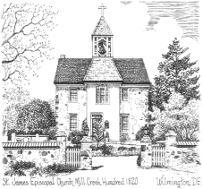

**A Letter from St. James**

**November/December 2012**

Non-Profit Organization

U.S. Postage Paid

Permit # 36

Wilmington, DE

St. James’ Episcopal Church

2106 St. James’ Church Road

Wilmington, DE 19808

Address Service Requested

   



    

**mangerc.wmf**

**Join us Christmas Eve**

4:00 PM Family Communon

8:00 PM Youth-led Communion Service

11:00 PM Traditional Christmas Communon Service

**Christmas Day**

9:00 AM Christmas Communion Service

Rector: The Rev. James M. Bimbi

Senior Warden: Bruce Vrana

Junior Warden: Carolyn Joynt

Office Contacts

Phone: 302-994-1584 / Fax: 302-994-3778

Email: office@stjamesmillcreek.comcastbiz.net

Website: stjamesmillcreek.org

Office Hours: 9:00 a.m. – 2 p.m.

Tuesday – Thursday

Closed Monday and Friday

**Service Times**

**Sunday- Summer Schedule**

8:00 AM Holy Eucharist

10:15 AM Family Choral Eucharist

**Wednesday**

10:00 AM Eucharist & Healing Service

6:15 PM Evening Prayer Service

♫♫ December 8, 2012 7 PM in the church

A Very Jazzy Christmas

by Opus One Jazz Ensemble

♫♫

*Benefits Familt Promise & ERD Disaster Relief*