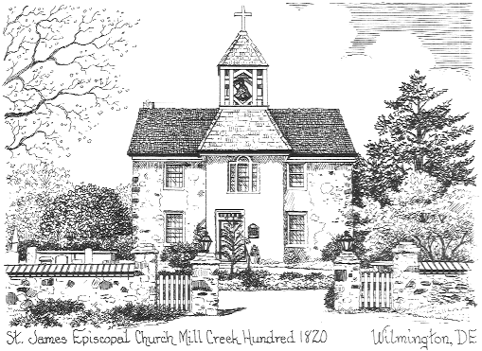 **St. James’ Episcopal Church**

**Mill Creek Hundred**

**2106 St. James Church Road**

**Wilmington, Delaware 19808**

The Rev. James M. Bimbi, Rector

Organized A.D. 1714

June 27, 2013

To our family of St. James’ Mill Creek:

As many of you may know, your Vestry and Rector have been engaged in a continuing conversation and discernment over the past year and a half regarding what they believe should be the church’s response to the blessing of same-sex unions. The conversation began after Delaware’s law regarding civil unions went into effect on January 1, 2012.

The discussion has been respectful and thoughtful, and centered on the question: “What would be our pastoral response to a member of our community who asks for such a blessing?” To frame the question within the context of relationships is to honor not only the persons involved but also to reflect upon the involvement of the church in the daily lives of its members. It is about how we celebrate and support the loving relationships and commitments of those who choose to be a part of this faith community, and to see within those relationships the handiwork of God.

The result of the Vestry and Rector’s conversations was to initially draft a written customary that would apply to any request for marriage or civil union ceremonies to be held in the church. The issuance of this was delayed as both the State of Delaware and the Supreme Court of the United States were considering matters before them regarding same-sex marriages. With those actions behind us, the proposed customary has been revised to apply to all lawful marriages in Delaware whether they be between opposite or same gendered persons.

You are invited at 11:00am on Sunday, July 14th , to come to a “holy conversation” regarding this manner. Before doing so, please take the time to read the proposed customary (a copy is printed on the back of this letter) and to give prayerful consideration to what you might want to take away from the conversation. While it is not expected that everyone will embrace the position expressed in the customary, it is hoped that mutual respect and concern will not break the bonds of affection that bind us together in Christ.

A Parish Customary Regarding Marriages

held at

St. James’ Mill Creek Hundred, Wilmington, DE

The Parish of St. James’ Mill Creek, under the pastoral direction of the Bishop of Delaware, endeavors to conform its ministry to the Canons of The Episcopal Church, the guidance and directives of the General Convention of The Episcopal Church, the decisions of the Diocesan Convention of Delaware, and in accordance with appropriate laws of the State of Delaware.

With regards to marriage and the offering of the Church’s blessing, individual consideration will be given to all couples whether they consist of opposite or same gendered persons. The decision to allow and officiate at a marriage ceremony within the parish of St. James’ Mill Creek always remains within the discretion of the Rector, or in his/her absence the Vestry of the parish. The Rector’s decisions will be guided by prayerful and intentional pastoral practices, and in accordance with the following guidelines adopted by the Vestry:

* Only persons who are members or regular attendees of St. James’ Mill Creek, and who support the ministry of the church, will be permitted to have their ceremony held in the church. Consideration will be given to those who once were members but no longer attend regularly due to the distance of their current address from the church. Relatives of current members may also be considered on a case-by-case basis.
* As the marriage ceremony is to be conducted by an ordained Episcopal minister in the context of his/her ministry, it is required that at least one of the parties must be a baptized Christian.
* The parties must state their desire that their marriage is intended to be a life-long union lived in fidelity to one another, and to the best of their abilities in accordance with vows that they make.
* Pre-marriage relationship counseling must be completed with the Rector, or other approved clergyperson permitted to officiate at St. James’ Mill Creek. Additionally, the couple may be directed to complete a period of counseling with other qualified professionals.
* All ceremonies conducting within the church will be from The Book of Common Prayer, other liturgical resources issued and approved for use in The Episcopal Church, or in accordance with any guidance issued by the Bishop of Delaware.

File: Vestry 2013-14 / Marriage – Parish Customary (Revised draft 06-26-2013)