A Letter from St. James

Mill Creek Hundred

September 2012

*RECTOR’s RAMBLINGS . . . God Provides*

*One day an atheist moved into the house next door to a little old lady. The next morning the little old lady stepped onto her front porch, raised her arms to the sky, and shouted, “PRAISE THE LORD!”*

*This bothered the atheist, but since he was new to the neighbourhood he didn’t say anything to her. However, the following morning she again stepped onto her front porch, raised her arms to the sky, and shouted, “PRAISE THE LORD!”*

*Now he became irritated by the little old lady, and when on the third morning she did the same thing he stepped onto his front porch after her and yelled, “THERE IS NO LORD!’*

*Time passed with the two of them carrying on this way every day.  Then one morning, in the middle of winter, the little old lady stepped onto her front porch and shouted: 'PRAISE THE LORD!” and then added, “Please Lord, I have no food and I am starving. Provide for me, oh Lord!''*

*The next morning she stepped out onto her porch and there were two huge bags of groceries sitting there. 'PRAISE THE LORD!' she cried out. 'GOD HAS PROVIDED GROCERIES FOR ME!'*

*At that moment the atheist neighbour jumped out of the hedges and shouted: 'HAH! THERE IS NO LORD; I BOUGHT THOSE GROCERIES!!'*

*The little old lady threw her arms into the air and shouted: 'PRAISE THE LORD! GOD HAS PROVIDED ME WITH GROCERIES AND MADE THE DEVIL PAY FOR THEM!'*

My thanks go to Lynn Baker for passing along this amusing story. It does, however, produce more than just a laugh; it points towards the deeper truth that God can work in and through everyone: believers and seekers (I prefer not to label people non-believers for everyone is searching for something), old and young, rich and poor, charter members and new-comers, conservatives and liberals, or any other categorization you can think of. God is not limited and neither are we if we but trust in the hope we have through Jesus Christ.

Over the summer we have had several people come and begin to take part in the life of St. James’ Church. Some found us on their own and others came because they had been invited to come take a look by someone already here. We never know who is going to be living next door, or sitting in the next pew, but let us never neglect to praise the Living God who cares and provides for all his children. We need remember, however, that it may just be us whom God is using to welcome all who cross the path of our daily lives.

-- Blessings and Peace, Fr. Jim Bimbi

# **St. James Bazaar**

**BazaAR ANNUAL.tif**

**The 2012 Bazaar is rapidly approaching. The dates are Friday, November 2nd and Saturday, November 3rd. Be sure to mark your calendar.**

The Bazaar Ladies have been very creative again this year. We have quite a few new hand crafted items. There will be something for everyone; the raffle table, several new jewelry creations, holiday decorations, wreaths, floral arrangements, homemade goodies, and delicious food.

A special **“Thank You”** to everyone who has donated craft supplies, yarn, fabric, and hand crafted items. Each Tuesday we find donations outside our door. We have used many of them. They are all greatly appreciated. Your continued support helps keep our costs down and contributes to the success of the Bazaar.

If you have any questions about the Bazaar please contact Nancy Patterson (239-7649) or Eleanor Bowers (737-2163).

**ZINGO TAPES**

Please remember to save your Zingo tapes. They help offset the expenses of the Bazaar supplies. They can be placed in the container marked **Zingo Tapes** located in the lobby closet in the Parish House.

**SIGN UP to HELP**

On Sunday, September 30th, Sign-Up sheets will be posted in the Parish House requesting donations for the luncheon and turkey dinner. There will also be Sign-Up sheets for servers for the luncheon, turkey dinner and for helpers in the bazaar rooms and various other bazaar activities. Everyone working together makes this a fun and successful event.

More information is coming in October about the Luncheon on Friday and the Turkey Dinner on Saturday.

# **HOMEMADE GOODIES FOR THE BAKE SHOP**

# It is time to start planning what you will be making for the Bazaar Bake Shop. We are looking forward to your donations of *baked goods, jellies, jams, pickles, candies and soup mixes.* Your delicious homemade items are always a favorite with all our customers each year.

***school_3131.tifTHANK YOU!!!!!***

The Mission/Outreach committee thanks you for your generous support of this year’s **back-to– School** program. You donated $1,185 to this wonderful program to help underprivileged children start school with the supplies they need. **Thank you!**

**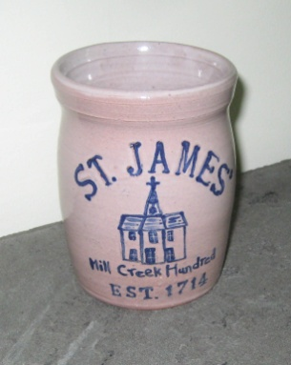The St. James’ Tercentennial Crock is popular!**

Thanks to the efforts of Susan Fentzloff, a Tercentennial Crock has been made by local pottery artist Maggie Creshkoff. The 4 3/4 inches tall crock is made from local clay using traditional methods and styling, Each one is individually hand thrown, hand stamped and drawn upon, lettered and glazed. The artist indicates that they all will be similar, but they will vary. The face of the crock displays the text "St. James’ Mill Creek Hundred, EST 1714", which surrounds an image of the church building. A stylized scallop shell, the symbol of Saint James the Apostle, is displayed on the reverse side. Crocks are being sold for $35.00 each. Order forms are available in the Parish House or by calling the church office (302) 994-1584.

**fleamarket1877c1_print.tif**

Carolyn Eldridge and Dave Perry will be chairing our annual Flea Market again this year. It will be held on March 23, 2013. Don’t forget the Flea Market as you do your fall house cleaning. Remember that anything must be in clean, usable condition. We ask that you ***do not bring any electronics*** (computers, printers, etc) as they do not sell and we have no way to dispose of them. The flea market area (downstairs through the double doors) is available so that you can bring in items when you want rather than having to store them until March. We thank Carolyn and Dave for doing this again this year. Look for them to call on you for help when the date gets near.

**Food Shelf and Sundry Closet**

 We are a group of eight who oversee the food closet shelves for the needy-trying to keep enough non-perishable items on hand. We depend on our parishioners to donate items such as dry cereal, canned fruits, canned veggies, dry pasta/rice/sauce, tuna, canned pasta meals etc. The food supply always seems to get sparse towards the end of each month. The expiration dates are periodically checked to keep the items "safe".  Items placed in the church food basket are taken to the parish house where we place the items on the marked shelves. The food closet is located in the closet to the right inside the front doors (curtains hang at the doorways). Fr. Jim and Genia oversee the folks that come in needing food. If you would like to join us in this ministry, please notify Fr. Jim, Genia, or any of the food closet volunteers. For any questions, please call Barbara Anzilotti (302-737-3612). If you can donate items to the St. James' food closet, the following would be very helpful:  peanut butter, tuna, fruit in easy-open containers, small canned meats, cereal, mac & cheese, toilet paper, crackers and cookies in individual packs.  Donations are always welcome - the need is great.  Thank you very much.

## schedule back to reg.tifWorship Services – Sundays at 8 & 10:15 Starting September 9

## *September 2 will be the last of the 9:30 services for 2012.*

## The diocese gathers every November

[](http://parishlifeday.eventbrite.com/) **EVENT SCHEDULE**

**8:30** Register & Browse Displays

Continental Breakfast

**9:15** Gathering Worship

Bishop’s Message

**10:00** Break

**10:10-11:40** MORNING Workshop

**11:45** Lunch & Browse Displays

**12:45-2:15** AFTERNOON Workshop

will be held on

# Saturday, November 17, 2012

[at St. Anne's Episcopal School](http://www.saintannesschool.org/)  
211 Silver Lake Road  
Middletown, DE 19709

**2:25** Door Prize Drawing

Announcements

Children’s Presentation

**2:45** Closing Worship

**3:15** Go In Peace

WORKSHOPS OFFERED:

* Poetry Writing: Poet Maggie Rowe is back by popular demand!
* Digital Evangelism: Introduction to integrating your website and social media to tell your faith stories - Lee Ann Walling of Kairos Communications
* Making the Square Circle: How we can work the shape-note singing tradition into our own worship music -Parker Kitterman, Director of Music—Christ Church, Philadelphia.
* Tai Chi - Susan Hamadock, of Silver Lotus Training Institute, Lewes.
* Spanish as a Second Language/Pastoral – The Rev. Juan George
* Beating the Beads . . . Praying with our hands as well as our hearts-Sr. BJ Brown and Sr. Julian Wilson of Anamchara Fellowship.
* ‘Centering Prayer- - Hands on! - The Rev. Tom Hughes and Francie Thayer
* Storytelling for Preaching, Teaching, and Pastoral Care - The Rev. Joanne Epply-Schmidt, Episcopal
* "LET"TUCE EXPLORE AND "FIG"URE OUT HOW TO MAKE HALF MY PLATE FRUITS AND VEGGIES by The University of Delaware Cooperative Extension.
* Art of “Divine Flower Arrangements” - Floriculturist, Al Weber *There is an additional $6 supply charge for this workshop.*
* Bible Study with The Rev. Joe Rushton
* ECW - Delaware Annual Meeting: Approve Annual Budget, Election of Officers Annual Business Meeting. All who plan to attend this meeting will need to complete the Parish Life Day registration.

Registration forms are available in the Parish Hall or by calling the parish office or check it out and register online at [www.dioceseofdelaware.net](http://www.dioceseofdelaware.net). The first 75 people to register online will receive a diocesan spooner cup. Cost is $20 which includes continental breakfast, lunch and workshops. There is a free program for children.

**WELCOME BACK**

**ST. JAMES’**

**RODEO**

****

**á la foot**

**FOR ALL AGES**

* **NO EXPERIENCE OR ANIMALS NEEDED**

**BBQ**

* **JUNIOR & SENIOR DIVISIONS**
* **EVENT CHAMPIONS**
* **ALL-AROUND CHAMPIONS**

**BARREL RACING**

**POLE BENDING**

**FLAG RACE**

**SUNDAY, SEPTEMBER 9TH**

**ST. JAMES’ CHURCH PARKING LOT**

**2106 ST. JAMES CHURCH ROAD**

**9:30 A.M. RODEO REGISTRATION**

**SMACA REGISTRATION**

**9:45 AM. LIVE MUSIC & FELLOWSHIP 10:15 A.M. FAMILY WORSHIP**

**W/children’s sermon**

**11:30 A.M. ST. JAMES RODEO & BBQ**

**AWARD CEREMONY**

**For where two or three gather in my name,**

**there am I with them. -***Matthew 18:20*

At St. James we offer several different ways that people gather together to worship on Sundays and during the week. On Sundays, traditionally we have the 8 a.m. “said” Eucharist and at 10:15 a.m. we have a Choral Eucharist. Some Sundays we may have Morning Prayer. On Wednesday in the morning we have a Healing Service with Eucharist. And, on Wednesday evenings we have evening prayer led by a priest or sometime a lay reader. Whatever the type of service, it is an opportunity to reflect on God’s word and worship within the larger community of St. James.

***Have you ever wondered about the different opportunities there are to serve St. James as part of one of these services?*** Here is a brief overview of some of the different ways people serve and make our worship more meaningful.

**Altar guild**: The Altar Guild has the privilege of preparing the altar for every service including special services such as weddings and funerals.

**Ushers:** Assist by opening up the church before a service, greeting people and guiding them to a pew, providing guidance when people come to the altar rail for communion, and assisting with different parts of the service (collection, ringing of the bell before and after service, etc.)

**Lay Readers:** Assist by reading lessons and prayers and helping lead the people in different parts of the service. Eucharistic Visitors take communion from the service to those in our parish family who are unable to attend.

**Acolytes:** Assist by leading the procession in with a cross and candles, helping the priest in setting the table for Eucharist, and provide other support the priest may need during a service.

**Flower committee:**  Decorate the church to fit the different seasons of the church year or for special services, including weddings and funerals.

**Music Committee/Choir:** On January 1, 2012 Keith St. John joined our parish as Choir Director/Organist and has shared his many talents and deep commitment to enriching our worship and sharing God's love through music. All are welcome to attend choir

rehearsals on Thursday evenings starting at 7:30 p.m. in the choir room in the parish hall and experience the joy and fun in singing God's praises.

We are thankful to have dedicated people who are serving St. James in one or more of these ministries. ***We hope you will consider learning more about one of these fulfilling ministries.***

*Please ask one of the people who are currently serving or Father Jim if you’d like to learn more.*

**choir19.tifCHOIR REHEARSALS RESUME**

**Thursday, September 6 at 7:30 PM**

Please contact our music director Keith St. John if you are interested in joining us so that he can have music ready for you. All are welcome to come and see if this rewarding ministry is for you.

|  |
| --- |
| **What are the grown-ups doing?** |
| http://download.newsletternewsletter.com/artlinelibrary/g/gi/girl_3560c.gif  The Sunday school teacher was teaching a group of youngsters about the Israelites in the Old Testament. She kept referring to the Jews as the “children of Israel.”   A little girl interrupted her, wanting permission to ask a question.   “Certainly,” the teacher responded.   “Well,” the child said, “you keep talking about the children of Israel. The children of Israel crossed the Red Sea. The children of Israel built the temple. The children of Israel did this and did that. Didn’t the grown-ups ever do anything?” |

**turkey dinner.tif**

**HELP WANTED! Are you a good coordinator?**

We are looking for someone to chair our annual turkey dinner. Last year’s chair Jerry Clark has updated the procedure manual and will be happy to talk to the new chair about the event. Talk to Father Jim or call the office if you are willing to serve. You’ll get lots of help from others in the parish. This year’s dinner will be held on November 3, 2012. Co-chairs could work well. Talk to a friend and then volunteer to help keep this 50 year old tradition alive at St. James’

**ST. JAMES CHURCH MILL CREEK**

**VESTRY MEETING MINUTES**

**AUGUST 13, 2012**

**PRESENT:** Fr. James Bimbi, Bruce Vrana, Sister B. J. Brown, Carolyn Joynt, Ann Kauffman, Bob Meckelnburg, Gail Zimmerman, Nancy Patterson

**ABSENT:** Olivia Jessup, Kathy Kwiatkowski, Debbie Nuss, Steve Prescott

The regularly scheduled meeting of the Vestry of St. James Church Mill Creek was called to order at 7:20pm. Fr. Jim led the Vestry in an opening prayer.

**MINUTES OF PREVIOUS MEETING:** Approved

**TREASURER’S REPORT:** Fr. Jim presented the Treasurer’s Report for Steve Prescott. The deficit is $23,000.

**UNFINISHED BUSINESS:**

**Civil Unions –** Civil Unions will be discussed at the Vestry retreat.

**Family Promise** – Renewal of the rental contract needs to be finalized. An inspection of the Rectory will be done. Bruce Vrana will meet with Family Promise later this month.

**Vestry Retreat –** The retreat will be held Saturday, October 6th.

**Tercentennial –** The Tercentennial Activity Coordinators will meet Sunday, August 26, in the Lounge.

Room 18, the Tercentennial Planning Room, has been cleaned out. A conference table and the historical files have been moved in there.

**Capital Campaign –** The Vestry will think about going ahead with a Capital Campaign. They will make a decision next month. The Property Committee is in the process of getting quotes for needed repairs/improvements to the Parish House bathrooms and other necessary repairs to the Parish House and Church.

**After much discussion the following motion was made, seconded, and approved:**

*In light of current financial reserves all discretionary spending will be curtailed pending further review and completion of a Capital Campaign feasibility study.*

**NEW BUSINESS:** No New Business.

**VESTRY GREETER REPORTS:**

There was a complaint about typing errors in the Bulletin at the 8am service.

We had one new family at the 9:30am service.

**RECTOR’S REPORT:**

The Rev. Paul Gitimu from Kenyawill be our guest preacher Sunday, August 19th.

Fr. Jim will be away visiting his granddaughter the 18th – 25th of September.

**COMMITTEE REPORTS:**

**WORSHIP:** At the committee meeting it was decided to continue using the different Eucharistic Prayers the rest of the year.

The schedule is: September – Prayer A

October – Prayer C

November –Prayer D except for the 1st Sunday (All Saints Sunday)

Advent and Christmas – Prayer B.

There is a need for Lay Readers, Acolytes, and Eucharistic Visitors.

**PROPERTY:** At the monthly meeting various projects were discussed.

**FINANCE:** We still need someone to volunteer to take over the duties of Treasurer.

**PARISH LIFE:** The committee will meet in September.

**TERCENTENNIAL/HISTORY:** Already discussed.

**MISSSION/OUTREACH/FAMILY PROMISE:**  Donations for the Food Closet are always needed. St. James will host Family Promise again the week of September 23rd.

**EDUCATION**: Cynde Bimbi has volunteered to assume the Sunday School responsibilities.

There being no further business, the Vestry meeting concluded at 9:10pm with the Close of Day Daily Devotion.

Respectfully Submitted,

Nancy Patterson

Clerk of the Vestry

** We host Family Promise the week of September 23rd.** If you can serve as an overnight host or dinner provider, speak with Jennifer Idell, Susan Winward or sign-up in the Parish Hall. This is a most rewarding ministry for both those who serve and those who are served.

**Our Sunday Morning Academy for Children and Adults (SMACA) starts up on September 9th with a rodeo and B-B-Q. Join us and check it out. Classes will begin on September 16th.**

****

**September Birthdays**

3rd Bob Sheppard, Sr.

4th Jim Healey

5th Nancy Patterson

Kenna Harrold-Mansk

6th James Insinga

8th George Elliston

Mark Rutkoske

Irene Udinski

Peter Lichtenstein

Christie Hale

9th Moriah Niehaus

11th John Bowser

Nathan Minor

12th Larry Heinold

14th Randy Dill, Sr.

16th Les Cansler

17th Dan Strecker

18th David Coverdale

Fred White

Matthew Fauerbach

19th Emma White

20th Carol Harrold

21st Donna Mosel

Robert Haywood

22nd Paige Minor

Bill Fentzloff

23rd Mackenzie McCracken

28th Pat Minor

Courtney Sheppard

Hope Jennings

29th Ruth Gooding

Jim Minor

30th John Miller

Irma Shepsko

Waylon Loveless

**Happy Birthday to all!**

*If we missed your birthday or anniversary, please call the office and let us know. You are an important member of our parish family.*

**September Anniversaries**

6th Loretta & Bill Perry

8th Jane & Harry White

13th Marisa & David Morales

18th Debbie & Eric Dunford

19th Jennifer & Mark Idell

28th Carolyn & Sean Joynt

30th Kathryn & Steve Coverdale

**

**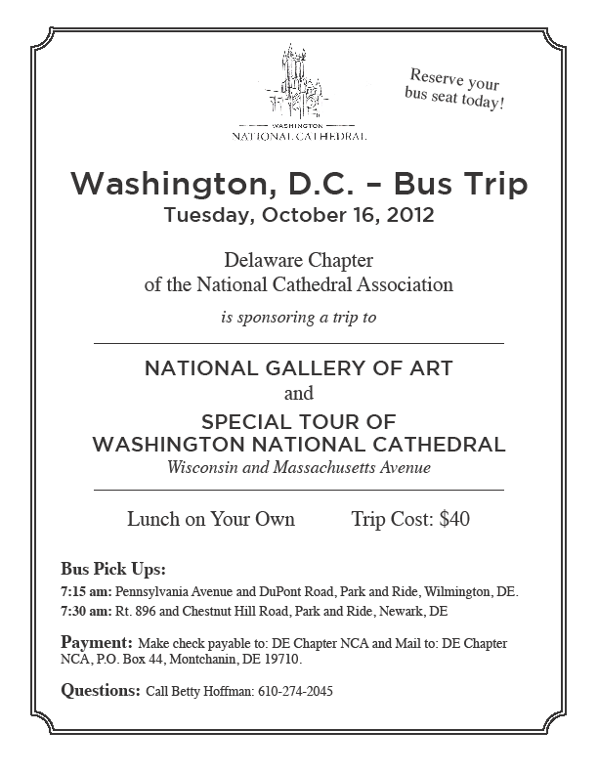thank you - note.tif**

Thank you to everyone for your cards, calls, visits, and prayers during Larry’s recent surgery and successful recovery.  We appreciate the thoughts and good wishes from our St. James’ family.  Peace,

*Allyson and Larry Heinold*

Cathedral Church of Saint John Memorial Book

available for purchase for $22

Contains photos and historic information about St. John’s.

[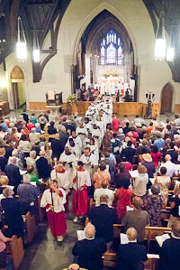](http://www.cathedralsaintjohn.org/deanLaneClosingLetter.html)

For more information or to order please call Cindy Timko at

(302) 654-6279 or (302) 528-8025

**A Letter from St. James**

**September 2012**

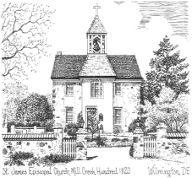

Non-Profit Organization

U.S. Postage Paid

Permit # 36

Wilmington, DE

St. James’ Episcopal Church

2106 St. James’ Church Road

Wilmington, DE 19808

Address Service Requested

   



    

September 9

Rector: The Rev. James M. Bimbi

Senior Warden: Bruce Vrana

Junior Warden: Carolyn Joynt

Office Contacts

Phone: 302-994-1584 / Fax: 302-994-3778

Email: office@stjamesmillcreek.comcastbiz.net

Website: stjamesmillcreek.org

Office Hours: 9:00 a.m. – 2 p.m.

Tuesday – Thursday

Closed Monday and Friday

**Service Times**

**Sunday- Summer Schedule**

8:00 AM Holy Eucharist

10:15 AM Family Choral Eucharist

**Wednesday**

10:00 AM Eucharist & Healing Service

6:15 PM Evening Prayer Service

schedule back to reg.tif

Our worship services return to 8AM and 10:15 AM.

***and***

**SMACA Registration, Rodeo and BBQ**

**Follow the 10:15 service**