Saint James’ Episcopal Church
September 2012
Sunday | Monday | Tuesday | Wednesday | Thursday | Friday | Saturday
 |  |  |  |  |  | 1
2  8:00 a.m. HolyEucharist  9:30 a.m. Holy Eucharist  11:30 a.m. Coffee Hour | 3    office closed | 4 | 5  Holy Eucharist  and Healing Service  10:00 am  Evening Prayer 6:15 PM | 6  PROPERTY COMMITTEE  7 pm  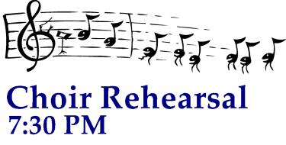 | 7  Office Closed | 8
9  WELCOME BACK SUNDAY  8:00 a.m. HolyEucharist  9:30 a.m. Registration  10:15 a.m. Holy Eucharis  11:30 a.m. Rodeo &  BBQ! | 10    Vestry -Lounge 7:15 PM  office closed | 11  PRIMARY ELECTION – Polling Place   | 12  Holy Eucharist  and Healing Service  10:00 am  Evening Prayer 6:15 PM | 13 | 14  Office Closed | 15
16  8:00 a.m. HolyEucharist  9:00 a.m. SMACA  10:15 a.m. Holy Eucharist  11:30 a.m. Coffee Hour | 17    1 PM - Lounge  office closed | 18   | 19  Holy Eucharist  and Healing Service  10:00 am  Evening Prayer 6:15 PM | 20 | 21  Office Closed | 22
23  FA M I L Y P R O M I S E H O S T W E E K  8:00 a.m. HolyEucharist  9:00 a.m. SMACA  10:15 a.m. Holy Eucharist  11:30 a.m. Coffee Hour | 24  office closed | 25   | 26  Holy Eucharist  and Healing Service  10:00 am  Evening Prayer 6:15 PM | 27 | 28  Office Closed | 29
30
8:00 a.m. HolyEucharist
9:00 a.m. SMACA
10:15 a.m. Holy Eucharist
11:30 a.m. Coffee Hour

